Ideation Phase
Empathize & Discover

Date | 28 November 2025
Team ID
Project Name | Book a Doctor
Maximum Marks | 4 Marks

Empathy Map Canvas:
Patients are overwhelmed, confused, and frustrated due to manual booking systems, lack of real-time availability, and long waiting lines. They desire a reliable, digital appointment system that simplifies the entire process.
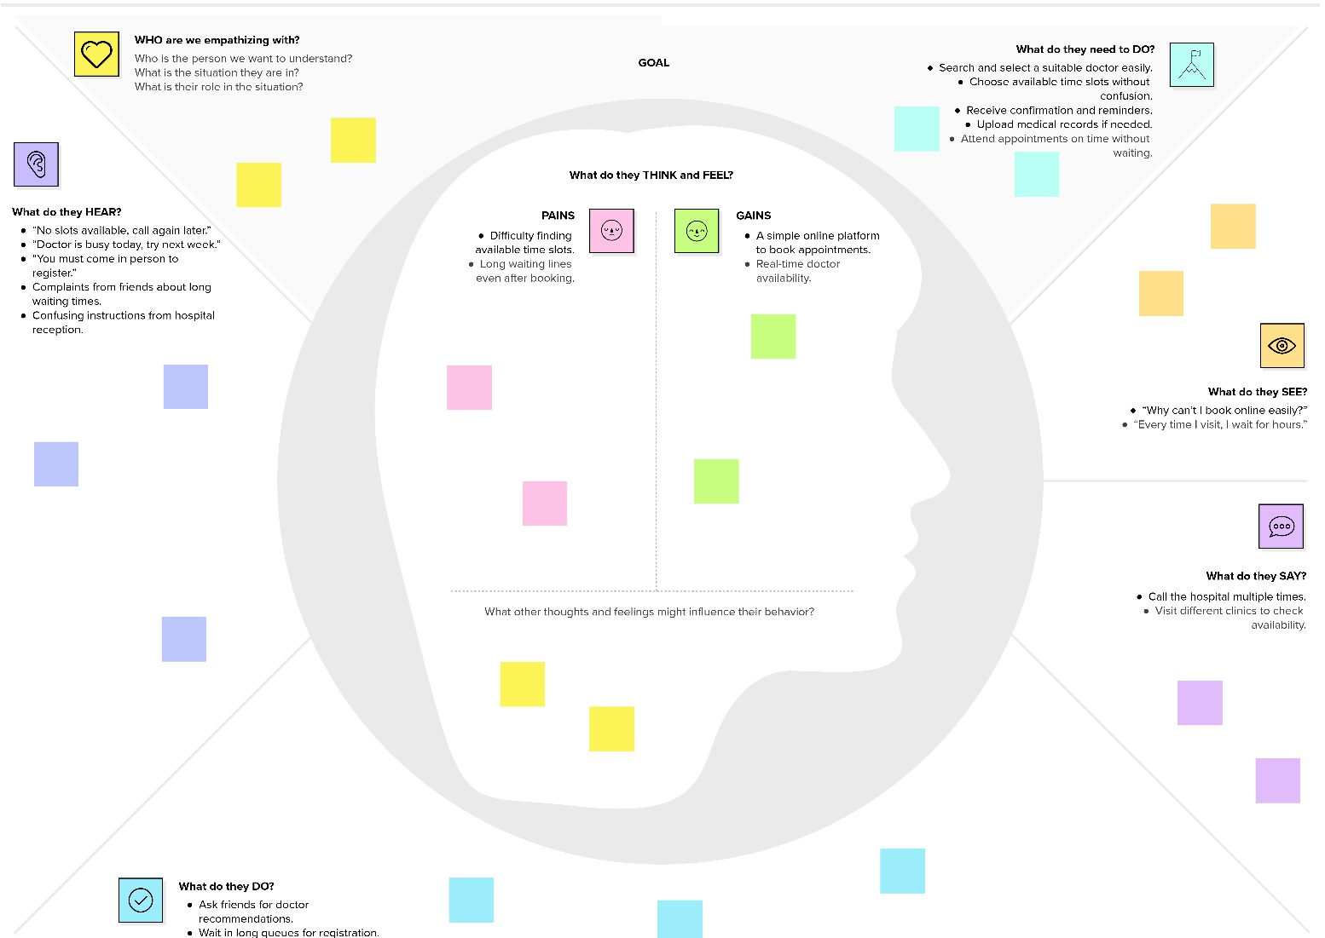

Reference: https://www.mural.co/templates/empathy-map-canvas

